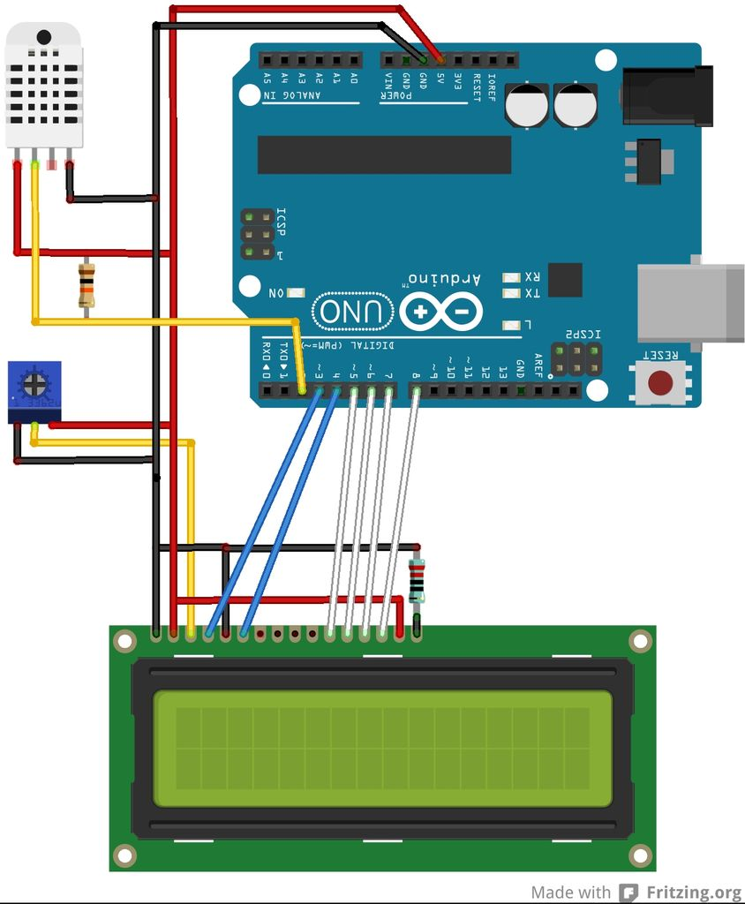

The LCD has 16 pins, 12 are used.  
  
  
Pin1 to Ground  
Pin 2 to +5V  
Pin 3 to 10K trimpot center  
Pin 4 (RS) to Arduino Digital Pin 3  
Pin 5 (RW) to Ground  
Pin 6 (E) to Arduino Digital Pin 4  
Pin 7 - Not Used  
Pin 8 - Not Used  
Pin 9 - Not Used  
Pin 10 - Not Used  
Pin 11 (D4) to Arduino Digital Pin 5  
Pin 12 (D5) to Arduino Digital Pin 6  
Pin 13 (D6) to Arduino Digital Pin 7  
Pin 14 (D7) to Arduino Digital Pin 8  
Pin 15 (Back Light +) to 5v  
Pin 16 (Back Light -) to ground via100 Ohm resistor)  
One side of the 10K trimpot goes to +5v the other side to ground  
  
See the schematic diagram and pictures.  
Note I have flipped the Arduino upside down in the "Fritzing" schematic to match the photo's and make the wiring neater.

**Step 5: LCD test sketch**